Listening
SKILLS TEST 1
1 Listen and number.  ⁰²
/ 5

a | 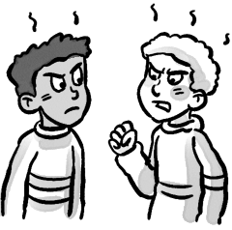 | b | 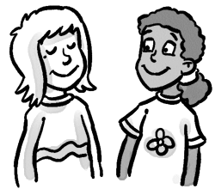 | c | 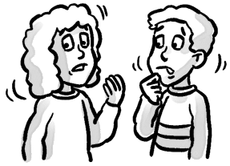 | d | 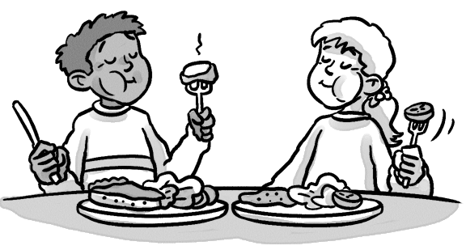 | e | 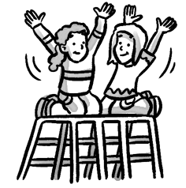 | f | 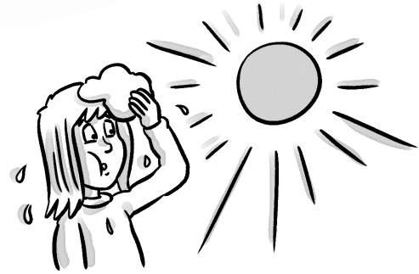
 |  |  | 1
2 Listen and check (). ⁰³
/ 3
/ 3
1 |  |  |  | 2 | 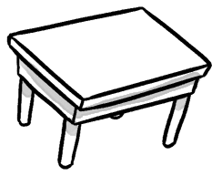 | 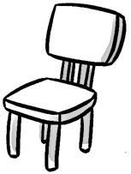 | 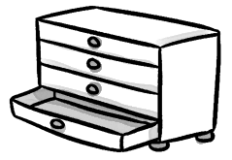
3 | 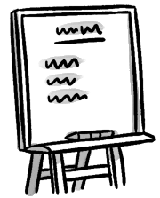 |  | 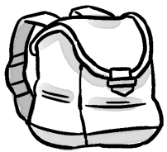 | 4 |  | 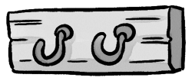 | 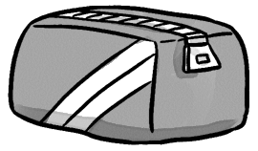
Reading
3 Read. Circle the correct answer.
/ 4
Hello! My name’s Daisy. I’m eight. This is my classroom. There are three tables and eight chairs. That is my teacher, Miss Green. She is in front of the board. There are two computers in my classroom. There are pictures on the wall. There are lots of coat hooks. My coat hook is blue. This is my bag, it’s yellow. | 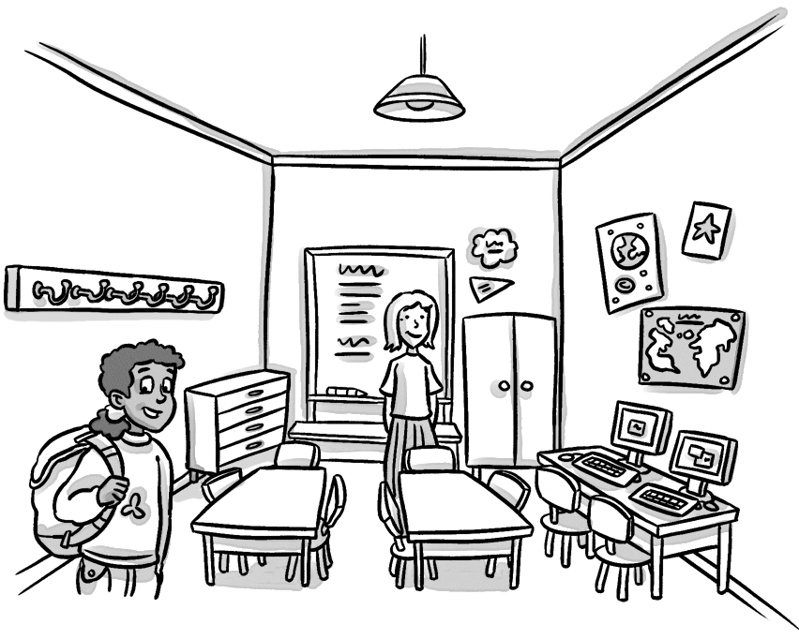
1 How many tables are there? three / four
2 How many chairs are there? nine / eight
3 How many computers are there? three / two
4 What color is Daisy’s coat hook? blue / yellow
4 Read again and write T (true) or F (false).
1 Daisy is nine. 2 Miss Green is Daisy’s teacher.
F
3 There are three computers. 4 There are pictures on the wall.
5 Daisy’s bag is yellow.

Writing

5 Complete the sentences.
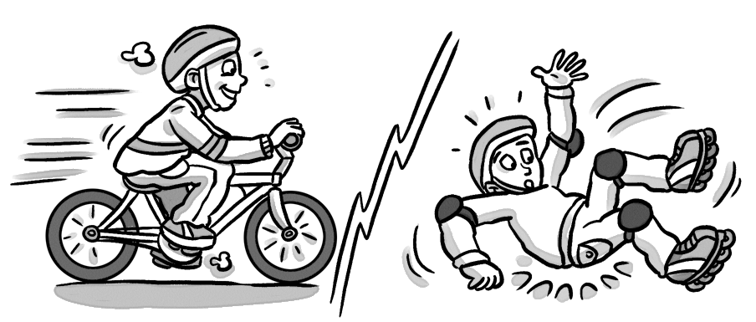 |  | 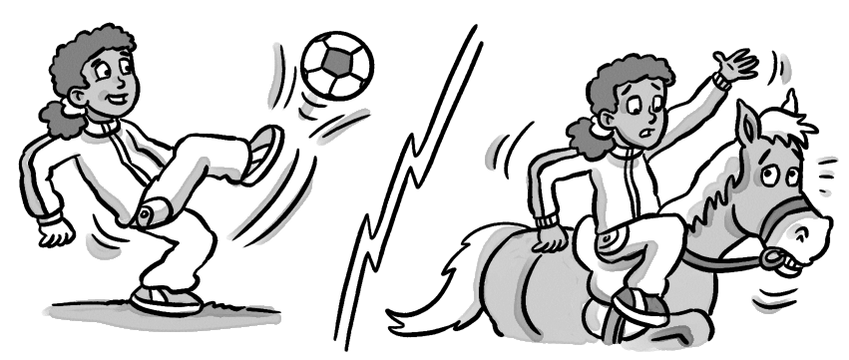
1 He can ride a bike.  2 He can’t skate. |  | 3 She play .  4 She ride a .
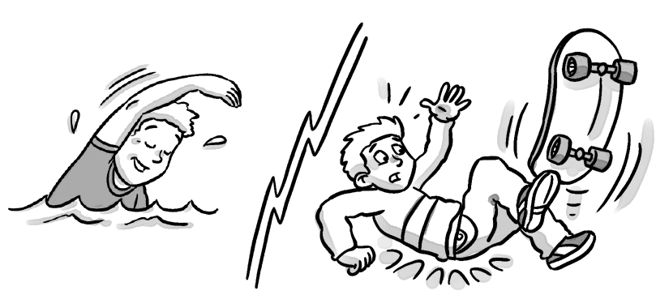 |  | 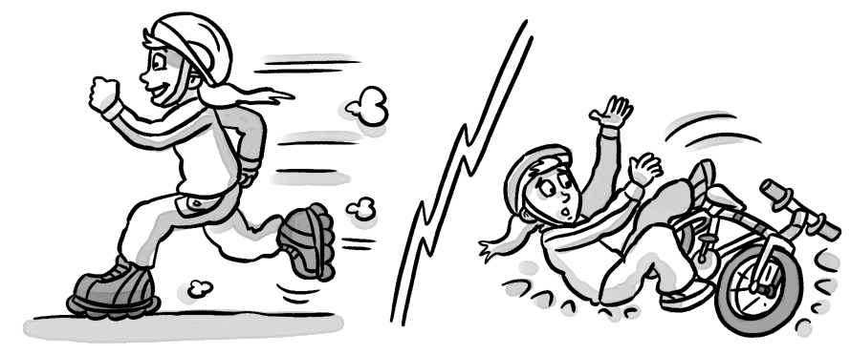
5 He .  6 He . |  | 7 She .  8 She a bike.

6 Write the short form.
/ 5
/ 4
/ 6
1 We are cold. We’re cold. 2 We are not scared. .
3 They are brave. . 4 They are not hungry. .
5 We are angry. .
Speaking
7 Look and answer.
/ 4
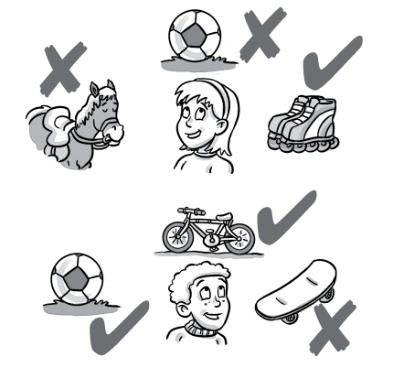 | No, she can’t.  1 Can Eva ride a horse?  2 Can she play soccer?  3 Can she skate?  4 Can Rob play soccer?  5 Can he ride a bike?  6 Can he skateboard?
/ 30

